1. **Create an Internal & External Load balancer(Verify It’s working).**

Ans. **Step 1: Creating an External Load Balancer on Azure**

* Step 1: Create a Resource

1. Log in to the Azure Portal and click on the Create a resource button in the top left-hand corner of the dashboard.
2. In the Search the Marketplace box, type "Load Balancer" and press Enter.
3. Select Load Balancer from the list and click Create.

* Step 2: Configure Load Balancer Basics

1. Select your Subscription from the dropdown list.
2. Choose an existing Resource group or create a new one.
3. Enter a Name for your load balancer.
4. Select the same Region as your VMs.
5. Select Public as the Type.
6. Choose the desired SKU (Standard or Basic).
7. Create a new Public IP Address or select an existing one.

* Step 3: Configure Frontend IP Configuration

1. Click Add a frontend IP configuration.
2. Name your frontend IP configuration (frontendip).
3. Select the public IP address you created or selected earlier.

* Step 4: Configure Backend Pools

1. Click Add a backend pool.
2. Name your backend pool (backendpool).
3. Select Virtual machines and add the VMs you want to include in the load balancer.

* Step 5: Configure Health Probes

1. Click Add a health probe.
2. Name your health probe (healthprobe).
3. Select the Protocol
4. Configure the probe settings:
5. Port: Enter the port number to use for the health probe.
6. Interval: Set the interval between health probe checks.
7. Unhealthy threshold: Set the number of consecutive failed health probe checks before considering the VM unhealthy.

* Step 6: Configure Load Balancing Rules

1. Click Add a load balancing rule.
2. Name your load balancing rule (loadbalancingrule).
3. Configure the rule settings:
4. Frontend IP: Select the frontend IP configuration created earlier.
5. Backend pool: Select the backend pool created earlier.
6. Protocol: Select the protocol to use for the load balancing rule.
7. Port: Enter the port number to use for the load balancing rule.
8. Session persistence: Choose the session persistence method.

* Step 7: Review and Create

1. Review your settings to ensure everything is configured correctly.
2. Click Create to create the Load Balancer.
3. That's it! Your Load Balancer is now created and ready to use. existing one.
4. Region: Select your preferred region.

**Step 2: Similary create an internal load balancer.**

1. create an internal load balancer with a private IP address, say 10.1.0.4.
2. configure the frontend IP configuration to use the private IP address.
3. add lb-vm1 and lb-vm2 to the backend pool.
4. configure a health probe to check the health of the VMs.
5. configure a load balancing rule to distribute traffic between the VMs.

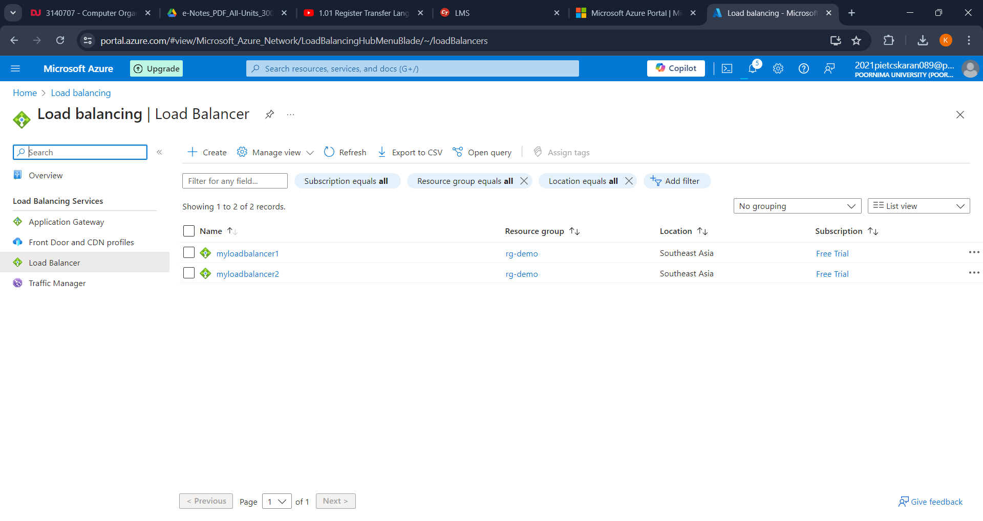

**Step 3: Set Up VMs and install web server as well as deploy applications.**

1. Navigate to "Virtual Machines" and create at least two VMs in the same region and virtual network (VNet).

* **Lb-vm1 and Lb-vm2**

1. **Install Web Server and Deploy Application**:

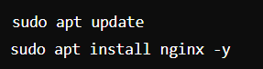

**Step 4: Working of Load Balancer**

**When a client sends a request to the load balancer's private IP address (10.1.0.4), the load balancer will:**

1. Receive the request and check the health of the VMs using the health probe.
2. If both VMs are healthy, the load balancer will distribute the traffic between them using the load balancing rule.
3. If one of the VMs is unhealthy, the load balancer will redirect the traffic to the other healthy VM.
4. Similarly, for an external load balancer, the load balancer will receive requests from the public IP address and distribute traffic to the backend VMs.